(Approx. 1049 words)

MuseScore – A Music Score Editor
By Dick Maybach, Member, Brookdale Computer Users Group, NJ
July issue, BCUG Bytes
www.bcug.com
n2nd (at) att.net

Amateur musicians frequently make notations on and corrections to the scores from which they play, to the extent that they can become illegible. Hand-written scores are tedious to create and edit and often difficult to read, and I was pleased to learn of a high-quality score editor in my price range (free). MuseScore is available at https://musescore.org/en for Windows, OS X, and Linux. Here I’ll just outline what it can do; you can download it’s 200+ page manual from the Website to learn more. It includes tools for voice and many modern, early, and ethnic instruments, both solo and group, including piano, bagpipe, hand bell, French Renaissance lute, and many more. I’ll use classical guitar music for this article, only because I play one.

You begin a new project by using a wizard, which guides you through setting the title and composer, instrument, and key and time signatures. The result is an empty score as shown in Figure 1.

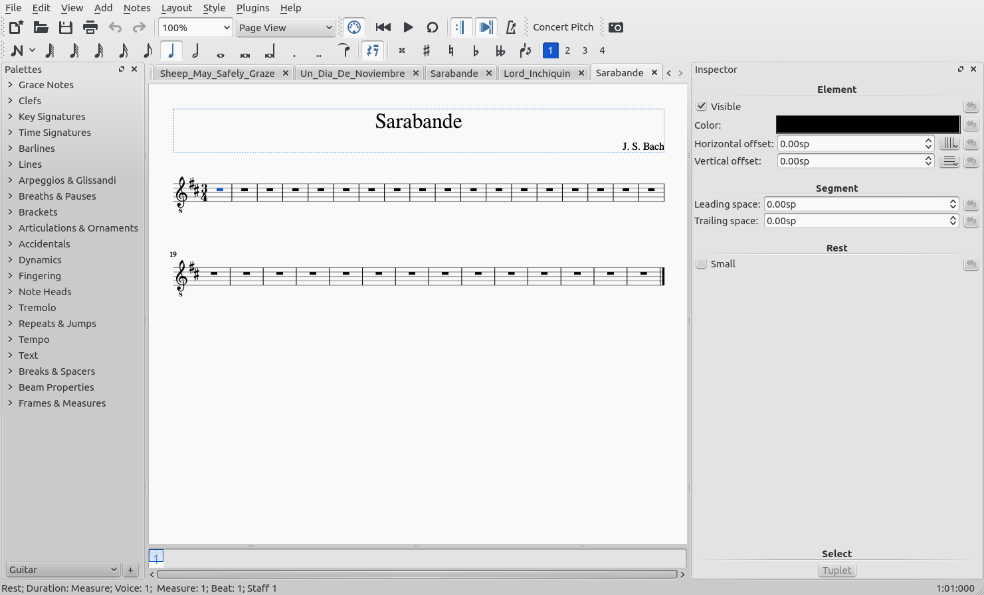
Figure 1. Beginning a New Score.

The workspace is much like that of a word processor. Toolbars at the top let you access common operations; the left sidebar holds a set of drop-down tool menus; and the right one shows operations pertaining to your current task.

To begin inserting notes, you select a measure and then the button that looks like a stylized N at the left of the third toolbar at the top. After choosing a note’s duration (again in the third toolbar), you can insert it with the mouse, type its letter, or select it on a piano keyboard, shown at the bottom of Figure 2.

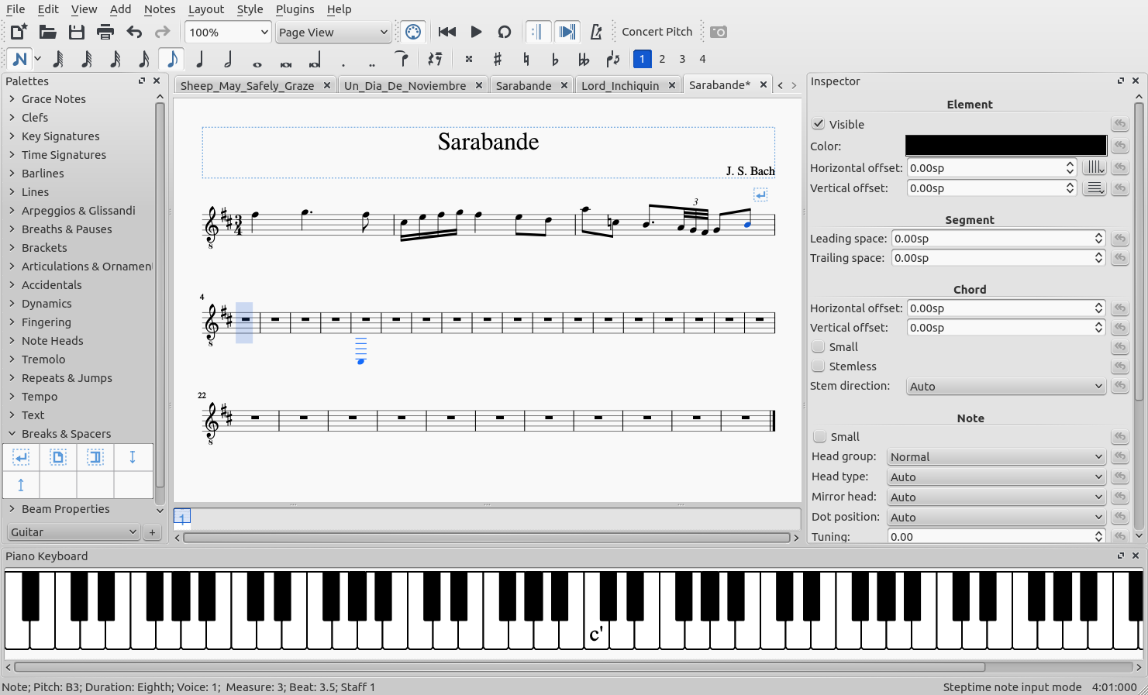
Figure 2. Entering Melody Notes.

I prefer to enter only the melody notes in the first pass, which is what I’ve done in Figure 2. Note the number 1 with the blue background in menu bar three, the blue shading in the first measure of line two, and the blue bass note in its fifth measure. All these show I’m working with Voice 1. I’ve forced a line break in measure 3, which is indicated by the symbol above the staff on the right. This is available in the Breaks & Spacers menu, shown open in the left sidebar.

When I’ve finished with the melody, I enter the harmony using Voice 2. Note in Figure 3 the number 2 with the green background in toolbar three, which shows this.
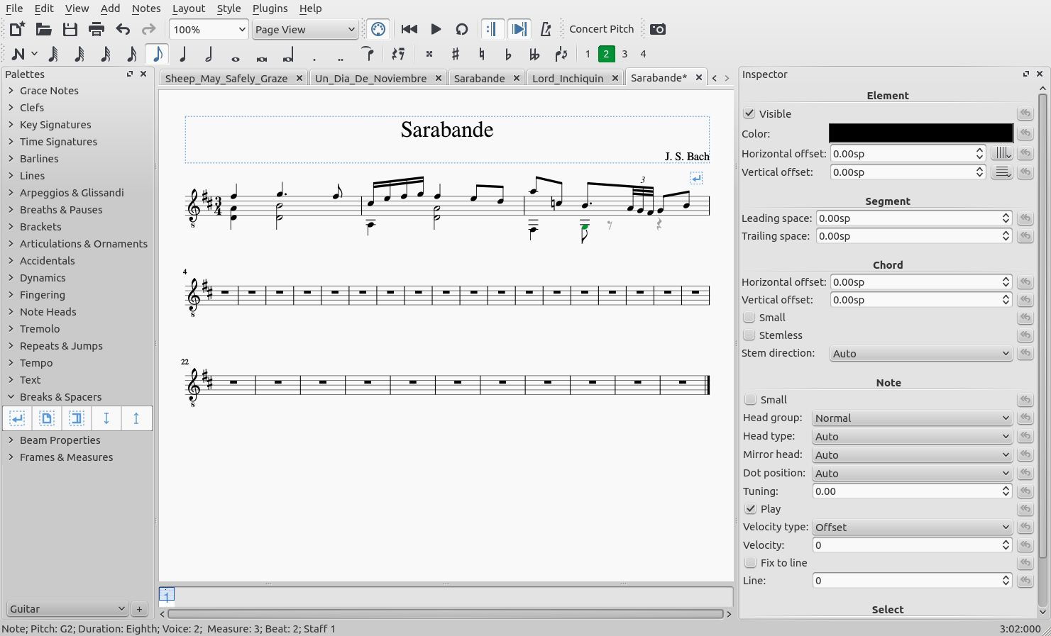
Figure 3. Entering Harmony Notes.

I used two voices in this example, because the harmony note durations are different from those of the melody. (Here, only voice 2 contains chords; but other pieces could differ.) We continue with the other lines; Figure 4, shows the process after two lines.

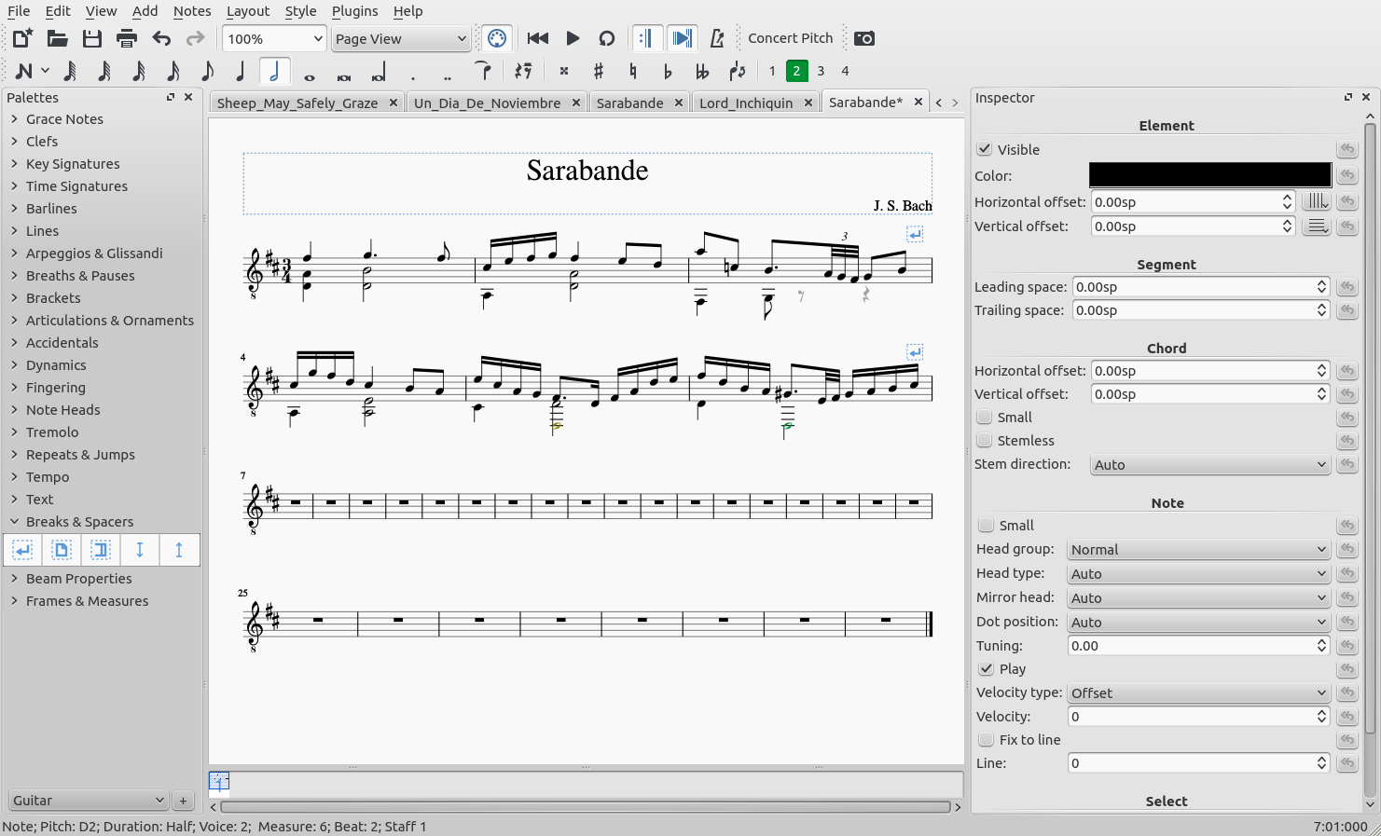
Figure 4. Second Line Complete.

I added another line break in line two to spread out the music and make the score more readable. The piece is of course longer than shown, but two lines are sufficient to illustrate the process.

After entering all the notes, I make a third pass to insert the slurs and ornaments, as shown in Figure 5.
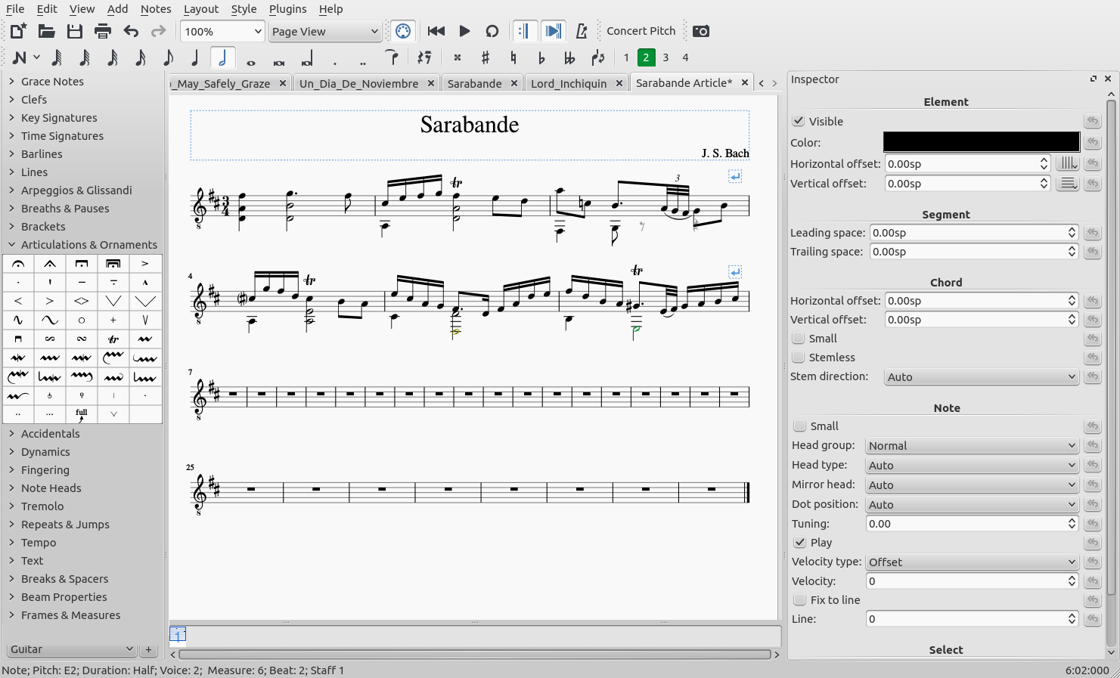
Figure 5. Slurs and Ornaments.

The trill ornament is available in the Articulations and Ornaments menu, shown open in the left toolbar.

We have only to add the fingering, which is shown in Figure 6. During this pass, I also corrected some errors I made earlier.

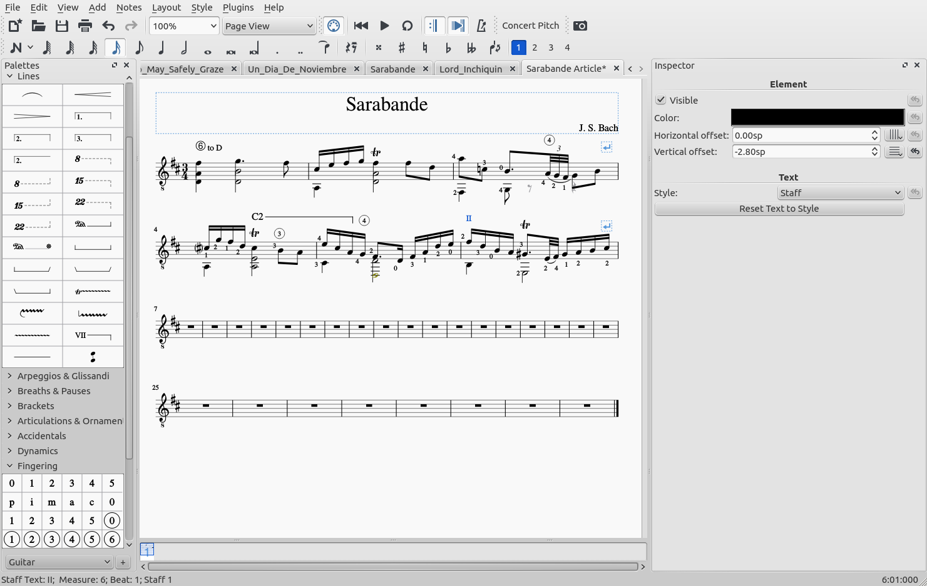
Figure 6. Fingerings.

I used the Fingering and Lines menus in the left sidebar to add these. The first two lines are now complete. Now that the music has been captured, we can explore the power available. For example, MuseScore will play scores, allowing you to hear what you’ve written. Some time ago I gave a printed score to a jazz guitarist friend who learned music by ear. He entered it into a similar program, so he could listen to it.

Some guitarists prefer their scores in tablature form, as shown in Figure 7.

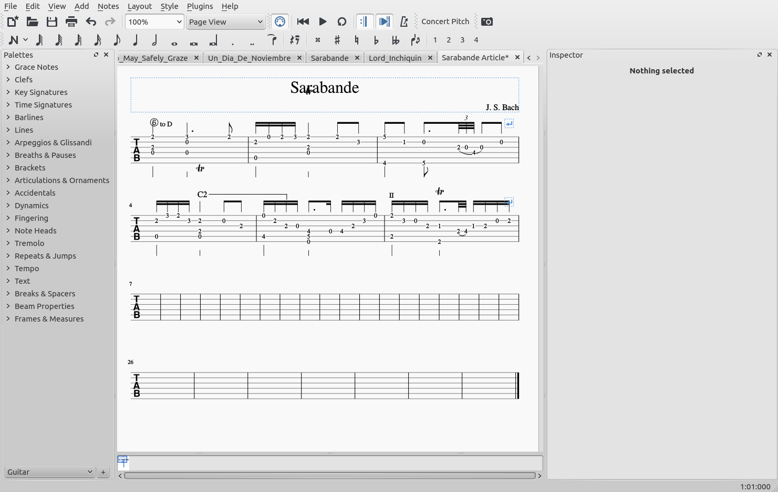
Figure 7. A Tablature Score.

Here each line represents a string, and the numbers the frets where a finger presses on it. (This is why the number of lines in the staff has increased to six.) It required only a few keystrokes to convert to this form.

Figure 8 shows another change that is easy with MuseScore, but quite tedious using pen and paper.

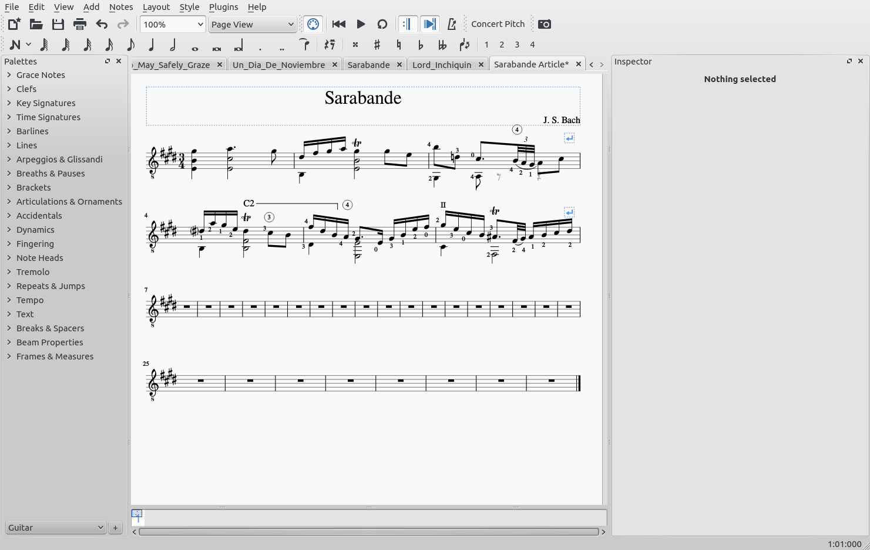
Figure 8. A Transposed Score.

The score has been transposed from the key of D to E, again with just a few keystrokes. To be fair, it probably needs touching up, as the fingering is surely different.

Once in a while you find guitar music in the bass clef, as shown in Figure 9.

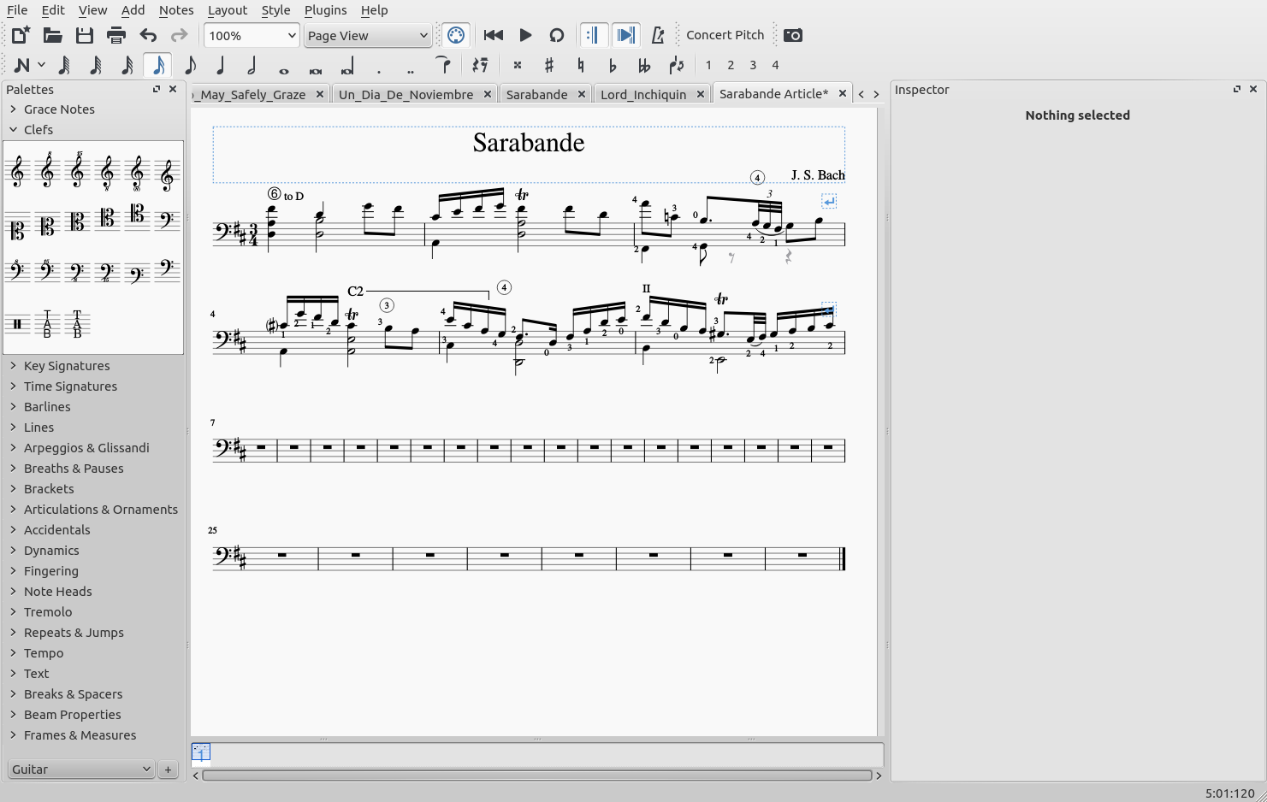
Figure 9. A Bass-clef Score.

Again, converting the score of Figure 6 to this by hand is ugly, but here it took only a few seconds (including finding how in the manual). MuseScore can also accommodate many less-used notations.

Figure 10 shows music in French Renaissance lute tablature.

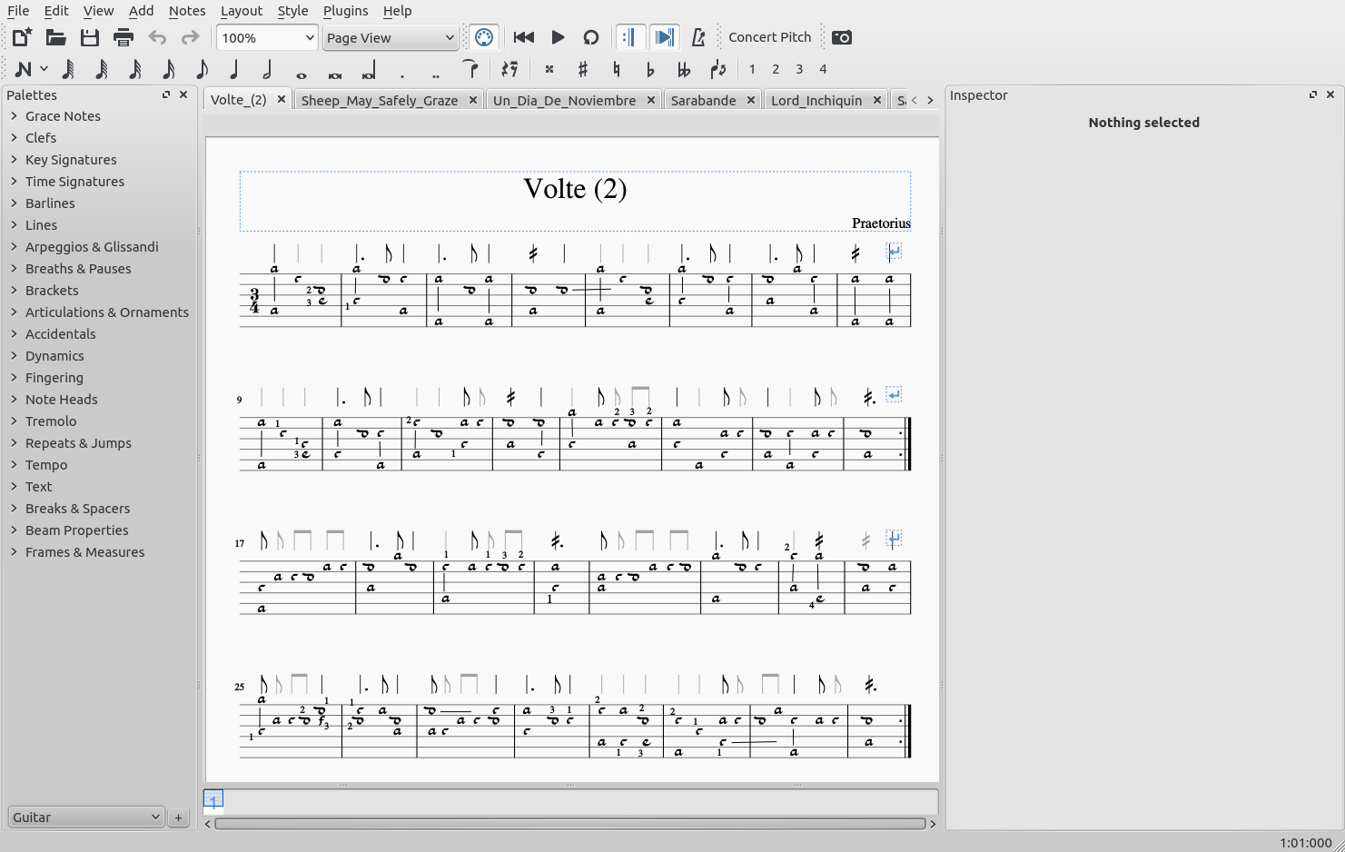
Figure 10. French Renaissance Lute Tablature.

Of course, if you aren’t comfortable with this notation, you can convert it to standard to obtain Figure 11.

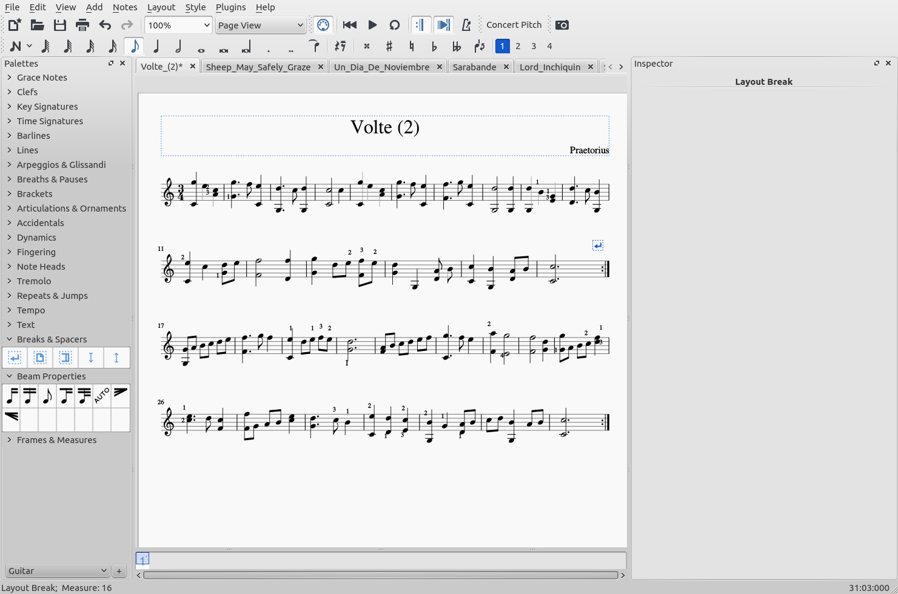
Figure 11. Lute Score in Standard Notation.

This conversion required tweaking, partly because I had made many customizations to make the tablature look the same as the original. It could use some further work, but this version is usable.

Using MuseScore to capture music is much like using a word processor to capture text, and once we’ve done this we can easily change it to a different key or to a different notation. We can make corrections, add fingering, and incorporate hand-written notes on old scores to make them more useful and more readable.

You probably have other interests, and most likely computer or smart-phone tools are available that would make them more enjoyable. Some research will no doubt uncover both free and commercial versions. While software reviews are helpful, I usually find that I must install and use a product to find how well it fits my needs. I always start with free ones, and seldom decide that I must purchase one. As always, be careful to download from a reliable source, and when you find a useful program, please consider donating to the project that supports it.

